Your Designer Cross
May 21, 2016

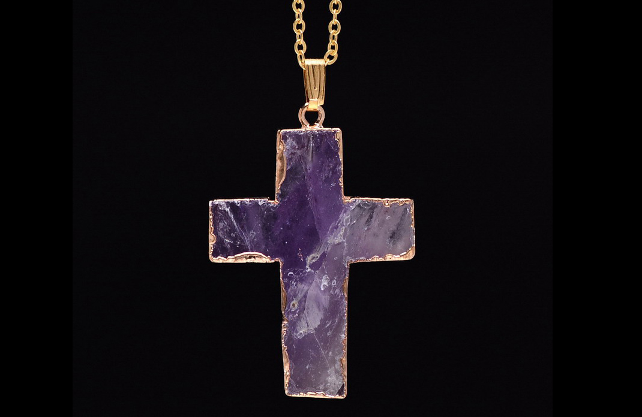
The Lord is Help, dear Heartdwellers and He has unique plans for each and everyone of us.

So, today I had a bit of nausea, and that's not unusual with Fibromyalgia. But I was really struggling when I came in to get the message, I was having a really hard time keeping it together. I began, after I came out of worship, I told Him, "Lord I am trying…. between nausea and more nausea... I've had a hard night, Lord."

He answered me, "I’ve been with you all night, My Love, all night. Right here by your side. I’ve never left you, not even for a moment.”

Oh, Jesus, I want to offer the things up to You. But I’m afraid my attitude isn’t the best.

He answered, "You are getting horrendous opposition, Clare, horrendous. But may I say, they are no match for Me?"

That’s for sure.

"So, we are doing a message in spite of their efforts to block you."

And here I am now, editing this message - and the nausea's gone. Hmmm.... interesting. As soon as I finished the message, or about half-way into it, I noticed that it was waning and now it's gone.

“My sweet dove, how comforting to hear you say, 'If I have to be sick, the best place for me to be sick is with You, Jesus.' Rather than going to bed, you’ve embraced Me and ignored the discomfort. Do you know how pleasing that is to Me?"

Well, I wanted You to know that You mean more to me than being sick, and I wanted to be with You, Jesus.

"And I wanted you here as well. You see, even when you are sick, you can glorify Me. You can keep Me company, and I keep you company as well. I know you’re on the edge, but you’ve chosen to persevere and that is so pleasing to Me.

"Just hang in there, this too will pass…no pun intended."

And here He's talking about a collie, which I had a vision of this puppy about 2 months ago. And that was actually when it was born. A bouncing little collie puppy. And he turns out to be a rescue. So, we're really thrilled. I just got an e-mail one day from some people that we had enquired of a couple months ago. And the Lord did prepare this way for me, He did give me a vision of this dog. And it's very sweet, really, the way He works.

And He said, "You have a puppy coming, you know."

Yes - I’m excited!

"He’s a little ragamuffin and a handful now, but he will settle down within 3 months. Until then, he will be a challenge. Lots of chew toys, lots of distractions and playing, lots of lessons with cats. He will be a pleasure, a joy and a challenge.

"I wanted this for you, Clare. You needed a joyful distraction. You both will get hours of pleasure from this little one. I will see to it. He will indeed be a new family member. The cats will endure him and get used to him, don’t worry about that. They have seen dogs come and go…in fact, they will wish he would go. 'Things were so much more peaceful before he came on the scene.' Nonetheless, they will play with him, it will be a novelty. We are going to have fun with him and this was truly My choice for you."

I was feeling nausea again, very sick to my stomach at this point and a little dizzy.

He repeated Himself. He said, "Dear one, this too will pass. Endure like a good soldier of Mine."

Jesus, I offer this to You for souls. Oh, how I love You. I know I can’t suffer much more than little things.

"There will be tests and trials in the coming days. Many tests and trials. You are entering a new plateau, climbing a new mountain as it were. Many will be tried in new ways, for as we go forward there must be progress. You must be always embracing more and more holiness, patience, humility, and steadfastness. These are the things that qualify you for advancement in My service. When you handle one level well, I advance you to new challenges in order to prepare you for new graces.

"I will be with you in all of this. It is for My glory and the salvation of souls. You know I never waste anything. Remember, everything is in My hands and it’s not about you - but My agenda. And graces will flow like a river.

"Your little flock, too, will advance in the ways of holiness. There will not be one day that does not have its challenges. Forewarned is forearmed. I wish for you all to stick together and be supportive of one another. This is the mark of My endtimes army: Brotherly Love. For however long you are here, I want you to advance in holiness, My Brides. There will be ample opportunity. Remember it’s not about prosperity, popularity, and power, but righteousness, peace and joy in the Holy Spirit in the midst of a corrupt and challenging world.

"Moments of triumph will be gratifying and I will reward each richly with the sweetness of My presence. The number of those who leave will decline, no one can argue against brotherly love and unity of purpose.

"All of you will be called upon to serve in some capacity, whether it be to help an elderly person across the street, or pray for the sick. The more confidence you have in Me, the greater results you will have in your prayers. Do not even consider your weaknesses, for each of you are wearing designer crosses. In other words, I Myself have fitted them to your size and strength in Me. There is nothing I will allow that you cannot master with My Grace.

"That is why I ask you not to consider your weaknesses, because My power will shine through your weaknesses and even surprise you with its results. Many of you have been walking this walk in your own strength. I am calling you to abandonment and confidence in My ability to carry you through storms and challenges.

"The less you think of yourself, the less you consider your skill sets and measure them to the challenges, the better. I need you to be focussed totally on Me and what I am doing through you. Just when you think it's all been a waste, that is when your breakthrough will come. I am prying you away from your own devices, your own abilities and tailoring challenges for you that will cause you to have complete confidence in Me because these things will be beyond your capacity to navigate.

"This is so very good for you. The less you think of yourselves, the more you consider My strengths, the better. What you would never dream of undertaking will flow right through you with very little effort if you are not counting on yourself, but counting on Me to do it.

"There will be many such tests. Your painting of Me, Clare, is one such test. Don’t be concerned about your lack of expertise, rely more on Me, My precious Bride. The more you rely on Me, the better the results. In the end, all of this will become so automatic in all of you. You will find yourselves declaring frequently, 'I can’t do this Lord, would You do it through me, please?' And even letting go, so I can, will come naturally to you once you overcome your tendency to want to control everything.

"Abandonment, abandonment, abandonment to the sacrament of the moment. Yes, each moment is a sacrament, a tool to bring you closer to Heaven. Don’t try to size it up and compare your ability, just cast your care on Me and move forward. I will truly do the rest. What makes a Christian great in My service is the ability to forego themselves in favor of Me, in everything. The greater your abandonment to Me, the greater your success. And the more I will shine from within you bringing healing to those around you.

"Understand, My idea of success is not the world’s idea. In the eyes of some, you may see yourself as a failure. It will be in these moments that you will be closest to Me and resemble Me the most. Do not look for worldly success, look for growth in holiness and abandonment to Me. The less you seek the world’s favor, the greater you will become in the Kingdom of Heaven.

"I know I have repeated Myself here, but it is for a good reason. These lessons will be so much easier if you retain what I am saying. They will come back to you, quickened by My Spirit. But still, it would be good for you to keep a copy and read it from time to time, to see just how accurately I warned you ahead of time.

"Again I ask you, please do not measure your abilities against the challenges. I am asking you to step out from under the cloud of your own self-reliance, which is poison in My Kingdom. Step out from under this and embrace the nakedness of not knowing, not having, not being experienced. Step out into the unknown and watch Me take over through you. You will literally be amazed at what I can accomplish through you. Do not be afraid. I am truly with you and will cause you to prosper spiritually in all circumstances.

"Remember: friendship with the world is enmity against God.
"Be wise as serpents, gentle as doves, and as dependent as a toddler just learning how to walk. These attitudes coupled with humility, patience, forbearance and brotherly love will cause you to succeed where most would fail.

"I love you tenderly, My Bride. Do not concern yourselves with timing of events. Concern yourselves with the sacrament of the moment and how I handle it through you. There will be many, many victories and new levels of holiness for those of you who take this to heart."

